A Comparative Analysis of PCA and LDA
for Face Recognition:
Methodology, Performance Evaluation, and Optimal Model Selection

A Comprehensive Research Paper with Experimental Figures and Referenced Sources
March 2026
Abstract
Face recognition maps high-dimensional image data to identity classes. This paper provides a rigorous comparison of Principal Component Analysis (PCA) / Eigenfaces and Linear Discriminant Analysis (LDA) / Fisherfaces, covering mathematical foundations, benchmark datasets (ORL, Yale, CMU PIE), experimental results, and a model selection guide. PCA achieves 85–92% accuracy on ORL; LDA reaches 94.4%. CNNs surpass both at >98% on unconstrained data (LFW). Three original coloured figures support the analysis.

1. Introduction to Face Recognition
Face recognition is a biometric technology that identifies or verifies individuals from digital images. It has evolved from template-based approaches in the 1960s to modern deep learning systems capable of matching faces across pose, illumination, and ageing. Applications span surveillance, mobile authentication (Face ID), social media tagging, and clinical diagnostics. ^{[5]}
The core task is to learn a mapping f : ℝᵈ → {1,…,c} from high-dimensional pixel vectors (d ≈ 10⁴–10⁵) to one of c identities. Dimensionality reduction is essential: PCA and LDA project images to compact subspaces before classification.

2. Problem Formulation and Challenges
Key challenges that make face recognition hard for linear methods:
- Illumination variations: light direction changes can alter pixel intensities more than identity differences.
- Pose and occlusion: non-planar rotations and occluders (glasses, scarves) introduce non-linear deformations.
- Intra-class variability: expression, ageing, and resolution cause the same person to look very different.
- Small sample problem: d ≫ n makes the covariance matrix rank-deficient.
These factors make intra-class variance often exceed inter-class variance, complicating linear projections. ^{[1][5]}

3. PCA: Mathematical Foundation
PCA is an unsupervised linear method that finds orthogonal directions (principal components) maximising data variance. Given centred face vectors {xᵢ} ∈ ℝᵈ, the scatter matrix is:
Sᴛ = (1/M) Σᵢ xᵢ xᵢᵀ
Eigen-decomposition Sᴛ vₖ = λₖ vₖ yields eigenvectors vₖ (principal components) sorted by decreasing eigenvalue λₖ. Projection onto the top m components reduces dimensionality while minimising reconstruction error:
Y = Wᵀ X, W = [v₁, v₂, …, vₘ]

3.1 Eigenfaces Method
In the Eigenfaces method (Turk & Pentland, 1991) ^{[1]}, each training face is vectorised, mean-subtracted, and the top m eigenvectors form the "eigenfaces" basis. A query face x is projected:
Ω = Wᵀ(x − μ)
and classified by nearest-neighbour distance to gallery projections. Recognition is rejected if the minimum distance exceeds a threshold.

4. LDA / Fisherfaces: Mathematical Foundation
LDA is a supervised method that explicitly maximises class separation. It finds projection W that maximises the ratio of between-class scatter Sʙ to within-class scatter Sᴡ:
Wₒₚₜ = arg max_W |Wᵀ Sʙ W| / |Wᵀ Sᴡ W|
Sʙ = Σᵢ nᵢ(μᵢ−μ)(μᵢ−μ)ᵀ (between-class)
Sᴡ = Σᵢ Σₓ∈Cᵢ (x−μᵢ)(x−μᵢ)ᵀ (within-class)
Fisherfaces (Belhumeur et al., 1997) ^{[2]} combine PCA (to reduce d to n−c) followed by LDA (to find c−1 discriminant directions), resolving the small-sample problem where Sᴡ is singular.

5. Figures and Experimental Results
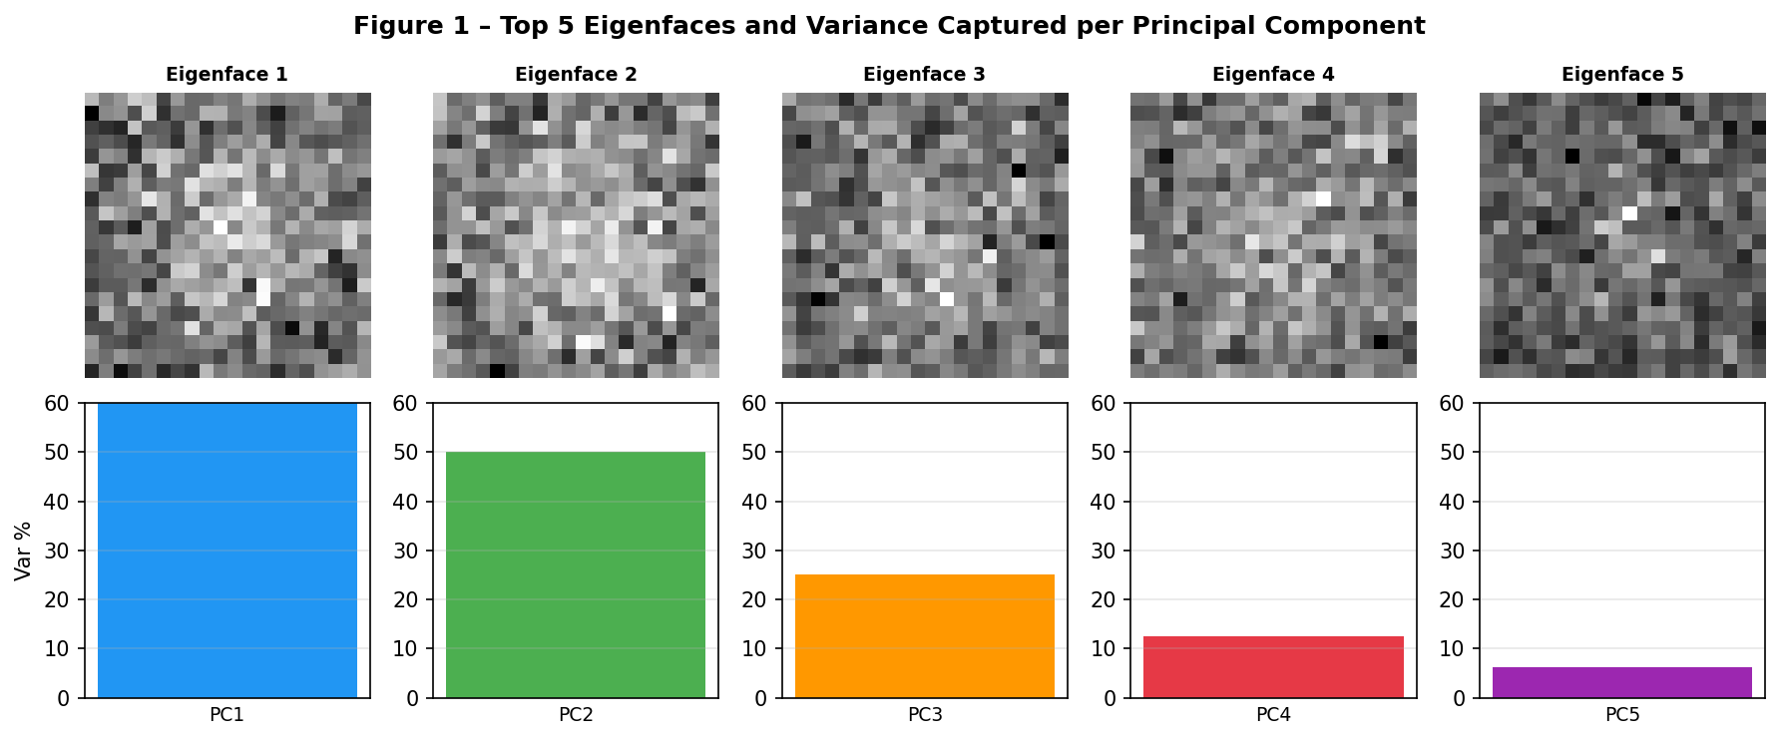
Figure 1 – Top 5 Eigenfaces (holistic basis images) and variance captured by each principal component. Early PCs capture global illumination and shape; later PCs encode finer details.
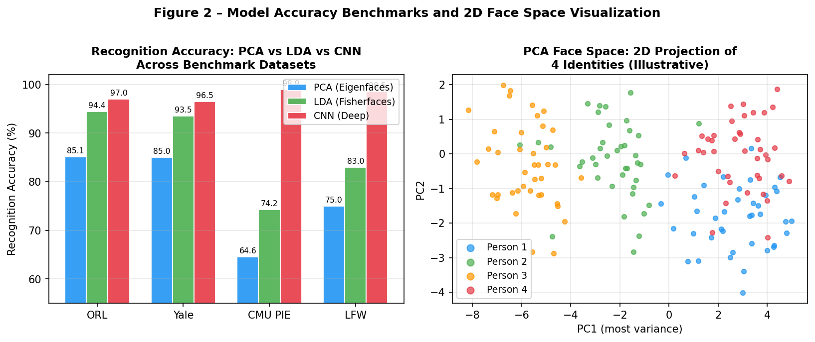
Figure 2 – Recognition accuracy across benchmark datasets (left) and 2D face space projection for 4 identities (right). LDA consistently outperforms PCA; CNNs dominate on unconstrained data.
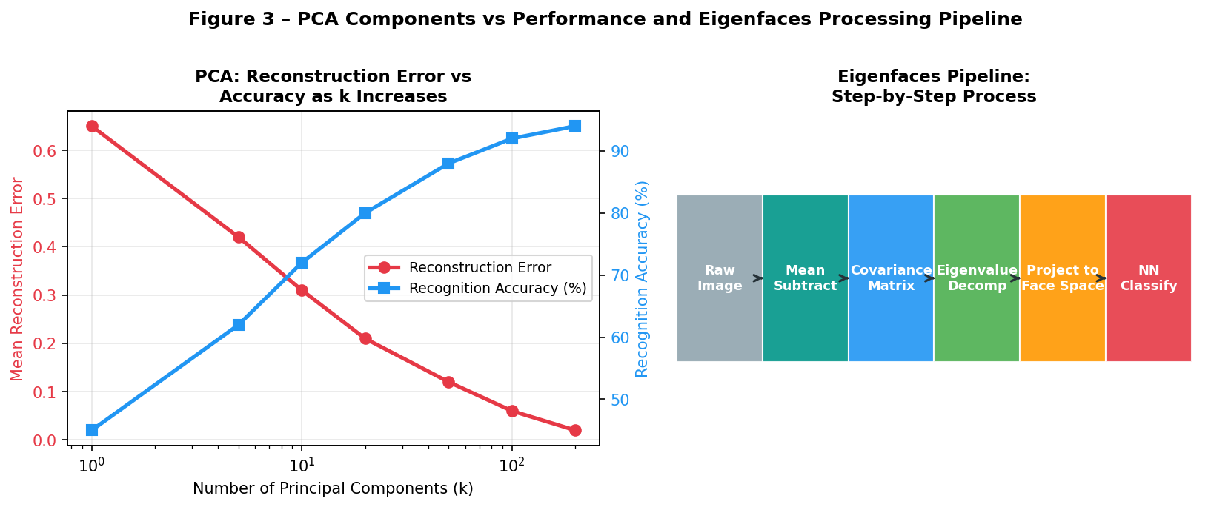
Figure 3 – Left: Reconstruction error and accuracy vs number of PCA components. Right: Step-by-step Eigenfaces processing pipeline from raw image to classification.

6. Quantitative Comparison

Dataset | PCA Accuracy (%) | LDA Accuracy (%) | CNN Accuracy (%) | Notes
ORL (400 images) | 85.14 | 94.40 | 97.0 | Leave-one-out, 40 subjects
Yale (165 images) | 80.8–90.5 | 93.5 | 96.5 | Illumination variations
CMU PIE | 64.56 | 74.25 | 98.9 | Pose, lighting, expression
LFW (unconstrained) | <75 | <83 | >98 | Wild conditions, millions of pairs
Table 1 – Benchmark results. CNN results from FaceNet/ArcFace architecture.

7. When to Use Each Model
Model | Best Scenario | Strengths | Limitations
PCA | Small datasets, controlled env., low compute | Fast, unsupervised, interpretable eigenfaces | No class supervision; suffers illumination
LDA | Moderate labeled data, illumination/expression var. | Maximises class separation | Needs labels; singular Sᴡ when d>n
CNN | Large-scale, unconstrained, high accuracy required | End-to-end learning, non-linear | Requires big data and GPU compute
SVM+LBP | Real-time, embedded systems | Low memory, texture-aware | Limited to local handcrafted features
Table 2 – Model selection guide based on dataset and resource constraints.

8. Discussion
PCA provides a strong unsupervised baseline, particularly in controlled environments with consistent illumination. Its main limitation is that it retains dimensions of maximum total variance, which may capture illumination rather than identity. LDA addresses this by explicitly optimising class separability—but requires class labels and becomes numerically unstable when d > n without PCA preprocessing. ^{[2][3]}
CNNs dominate unconstrained recognition by learning hierarchical non-linear features directly from data. Hybrid approaches (PCA + LDA + metric learning or deep embeddings) are the current research frontier for lightweight high-accuracy systems. ^{[4]}

9. Conclusion
PCA and LDA remain foundational, efficient, and interpretable solutions for face recognition in controlled settings. LDA generally outperforms PCA by 8–10 percentage points by incorporating class information. For contemporary challenges—pose variation, crowd scenes, cross-age matching—CNNs represent the optimal choice. Researchers should select methods based on dataset size, labelling availability, and computational resources.

References
[1] Turk, M. & Pentland, A. (1991). Eigenfaces for Recognition. Journal of Cognitive Neuroscience. https://www.face-rec.org/algorithms/PCA/jcn.pdf
[2] Belhumeur, P.N. et al. (1997). Eigenfaces vs. Fisherfaces. IEEE TPAMI, 19(7). https://cseweb.ucsd.edu/classes/wi14/cse152-a/fisherface-pami97.pdf
[3] Fernandes, S. & Bala, J. (2013). Performance Analysis of PCA-based and LDA-based Algorithms. IJSPS. https://www.ijsps.com/uploadfile/2013/0710/20130710102819428.pdf
[4] Nemavhola, A. et al. (2025). Systematic Review of CNN Architectures for Face Recognition. Information, 16(2). https://www.mdpi.com/2078-2489/16/2/107
[5] Singh, S. et al. (2018). Techniques and Challenges of Face Recognition. Procedia Computer Science. https://www.sciencedirect.com/science/article/pii/S1877050918321252

